Assignment No -: 14

Que 1-: Write a Command that puts the Following Values in their given order,into The Salespeople table: city-San Jose , name Blanco ,comm-Null,Cnum-1100.

Kd2_83598>create table salespeople2
-> as
-> select city,Sname,comm,Snum from salespeople;
kd2_83598>drop table salespeople;
kd2_83598>rename table salespeople2 to salespeople;
kd2_83598>insert into salespeople
-> values('San Jose','Blanco',Null,1100);
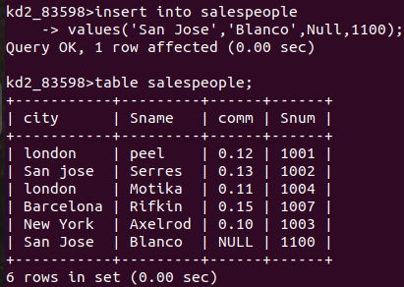

Que 2 -: write a Command that removes all orders from customer Clemens from the orders Table.

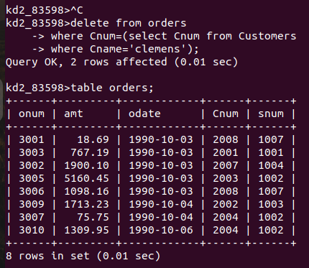
kd2_83598>delete from orders
-> where Cnum=(select Cnum from Customers
-> where Cname='clemens');

Que 3 -: Write a Command That increases the rating of all Customers in rome by 100.

kd2_83598>update Customers
-> set Rating=Rating+100
-> where city='Rome';
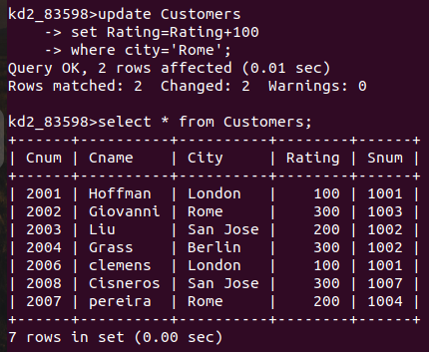

Que 4 -: Salesperson Serres has left the Company Assign her Customers to Motika.

kd2_83598>update Customers
-> set Snum=(select Snum from salespeople
-> where Sname='serres')
-> where Snum=(select Snum from salespeople
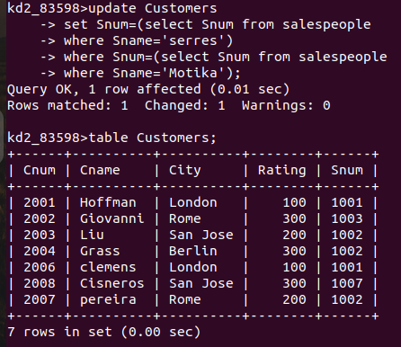
-> where Sname='Motika');

